METHOD OF PAYMENT Direct Debit Credit/Debit Card Cheque BACS Payment
Please tick as appropriate

MEMBERSHIP APPLICATION FORM

Company Name - Trading as:……………………………………………………………..……………..………………

Contact (Mr/Mrs/Ms/Miss) ...................................................Position..................................................................

Business Activities ...............................................................................................................................................

Address................................................................................................................................................................

.............................................................................................................................................................................

Postcode...............................................................................No of Employees:. ………………...........................

Tel No: ..................................………………………………... Fax No: ..............................................................…

Mobile No:………………………………………………………………………………………………………………..…

Web Site:….....................................................................…………………………………………………………..…

E-mail address – for Chamber Administration.:……………..…………………………………….…………………...

MEMBERSHIP DIRECTORY ON CHAMBER WEBSITE
Public Page: We will list your company name, website and telephone number. If you do not wish to have your contact number listed please tick here

Private Members Only Area: We will list your contact details excluding your email address on the downloadable members list, available for members only. If you do not wish to have your email address listed please tick here
Reasons for joining (please select):

Networking International / Export Business Advice
Publicity Representation Other
Other key staff to be circulated newsletters (please tick)
Events Newsletter Policy B2B’s

Name .................................................................................
Email Address …………………………………………………………….…………………………………………….…
Name .................................................................................
Email Address …………………………………………………………………….…………………………………….…

Name .................................................................................
Email Address …………………………………………………………………………….…………………………….…

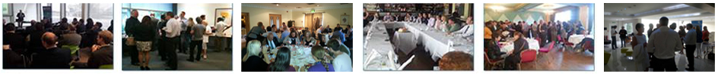

Please indicate if you would like to be involved with the following

Yes No

Wall Planner Advertising
Diary Advertising
Sponsorship
Thinking Business Magazine

Subscription Rates
Number Employees | Subscription Rates | Joining  Fee | TOTAL  Inc VAT (@ 20%)
1 - 9 | £ 199 | £30 | £274.80
10 - 19 | £ 249 | £30 | £334.80
20 - 49 | £ 319 | £30 | £418.80
50 - 99 | £ 429 | £30 | £550.80
100 - 199 | £ 609 | £30 | £766.80
200 - 499 | £ 959 | £30 | £1186.80
500 - 749 | £1329 | £30 | £1630.80
750+ | Negotiable
Please make cheques payable to ‘Kent Invicta Chamber of Commerce' and return to
Head office, Ashford Business Point, Waterbrook Avenue, Sevington, Ashford, Kent, TN24 0LH

I/We wish to apply for membership of Kent Invicta Chamber of Commerce, subject to the terms and conditions of the Memorandum and Articles of Association. I/We enclose herewith the annual subscription of £.................…...

Signed ................................................................................ Date ......................................................................

________________________________________________________________________________________________
For Office Use Only

Approved by:…………………………………….……….. Dated:…………………………………………..…..………

S:\iso9001\current\membershipform2014 Form311 Issue3 04/2014

